Trường: Tiểu học Thanh Quang  Họ và tên: ……....………………………  Lớp: …..…  Ngày 03/01/2019 | BÀI KIỂM TRA CUỐI HỌC KỲ I  MÔN TIẾNG ANH- LỚP 5  NĂM HỌC 2018- 2019  Thời gian: 40 phút

Marks: | Listening |  |  |  | Reading and writing |  |  |  | Speaking | Total
 | Q.1 | Q.2 | Q.3 | Q.4 | Q.5 | Q.6 | Q.7 | Q.8 | Q. 9

PART I. LISTENING ( 15 minutes)
Question 1. Listen and number. (1 pt)
Example: A.  0 | 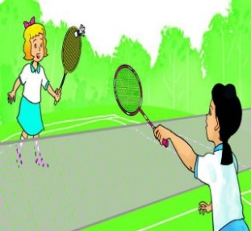  B. C.
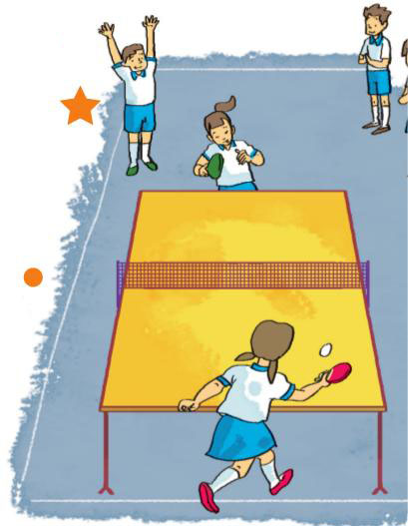  D. | .  E.
Question 2. Listen and write T (True) or F (False).(1pt)
Example:
- What are you reading?  I’m reading Snow White and the Seven Dwarfs. | F
- What are you reading?
I’m reading the Fox and the Crow
- What’s she reading?
She’s reading a funny story.
- What’s An Tiem like?
He’s generous.
- What’s Aladdin like?
He’s generous.

Question 3. Listen and circle a,b,c. (1pt)
Example:
0. Phong has Music ………….
a.Once a week b. twice a week c. three times a week
1. Mai has English........................................
a.every school day b. twice a week c. four times a week
2. Nam has........................................ today.
a. four lessons b. no lesson c. five lessons
3. Akiko is..............................................today.
a. at school b. at home c. on holiday
4. Quan has Maths..............................................
a. every school day b. four times a week c. once a week
Question 4. Listen and tick. (1 pt)

 | Aladdin and the Magic Lamp | The Fox and  the Crow | The Story of  Mai An Tiem | Snow White and  the seven Dwarfs
Example:  Quan |  | V
1. Nam
2. Mai
3. Linda
4. Tom

PART II. READING AND WRITING (20 minutes)

Question 5. Read and match.(1pt)

Example: 0.Do you like Vietnamese? | a. Yes. It’s break time. | 0 - c
1. How many lessons do you have today? | b. I have it every schoolday. | 1 - .......
2. Do you have school today? | c. Yes. I do. | 2 - .......
3. How often do you have Maths? | d. I have four: Vietnamese, Maths, Science and Art. | 3 - .......
4. Are you at school now? | e. Not today, but tomorrow. | 4 - .......

Question 6: Read and tick True or False (1pt).
Hoa usually goes to school in the morning. Yesterday was Sunday, so she didn’t have to go to school. In the morning, she went shopping with her family. They shopped for food and drink, and many things for the family. In the afternoon, they went on a picnic in the village. They sang, danced and had a nice food. The family enjoyed their day in the countryside and went back home late in the evening. Next weekend, they will go to Sa Pa. She hopes her family will have great time there.

Statements | True | False
Example: 0.Hoa usually goes to school in the afternoon. |  | v
1. Yesterday was Saturday.
2. Hoa’s family went shopping in the morning.
3. They sang and danced there.
4. Next week, they will visit the countryside.

Question 7. Look and write the missing words. (1pt)

Example: 0.do morning exercise | 1.pe_cocks | 2.st_ _ y of Mai An Tiem | 3. g _ rillas | 4. A_ t

Question 8: Put the word in order (1pt)
Example: 0.you/ Did/ to/ party/ go/ the/ ? /

Did you go to the party?

1. will / this/ Where/ weekend/ be/ you/ ? /
……………………………………………………….
2. I/ week/ . / have/ times/ three/ a/ it/
………………………………………………………..
3. watches/ Phong/ night/ . /every/ TV/
………………………………………………………..
4. do/ will/ Teachers’ Day/ ? / on / What/ you.
......................................................................................
PART III . SPEAKING (2pts) (5’)
Question 9. Interview
1. Listen and repeat | 2. Point, ask and answer
3. Listen and comment | 4. Interview

The End!

